Eureka server -> It’s server registry

Orthodox ways -> this is tight coupled as we need to remember the concerned urls exactly

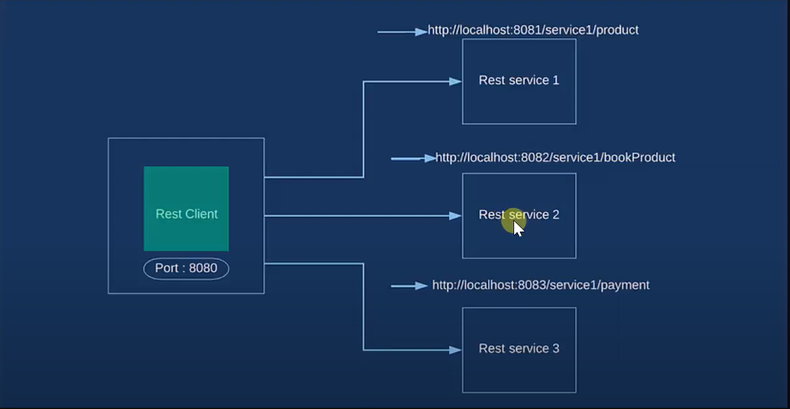

Microservices -> using eureka server, we register all the service which we need to use for our client

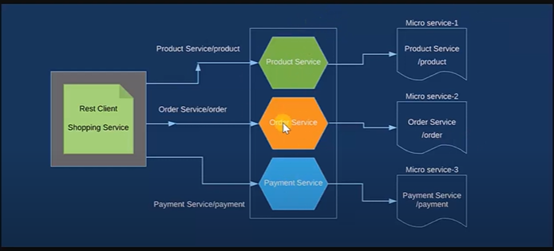

To make eureka server -> need to eureka server dependency in pom.xml

Need to annotate eureka serer config class with @EnableEurekaServer

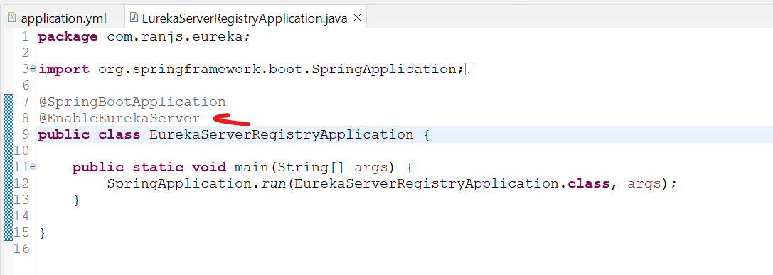

Create yml file in resource folder:-



And start the springbootapplication

Hit localhost:portno/

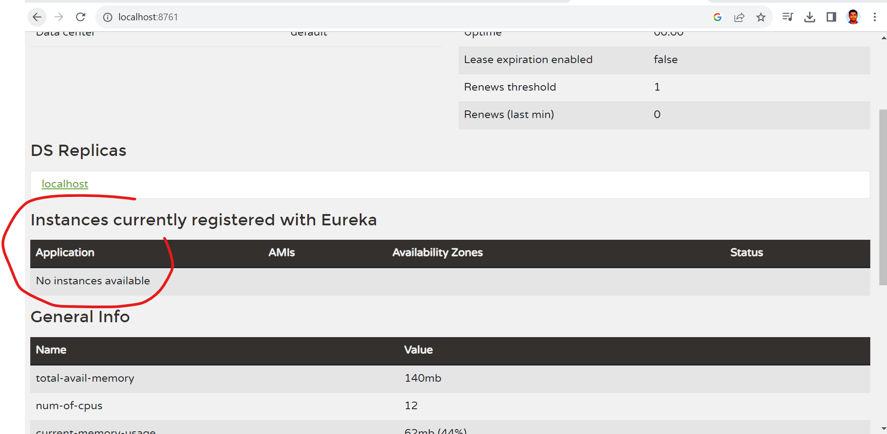

Initially no instance available, once we register some services they will reflect there.

To register service with eureka server -> need to add eureka discovery client in pom.xml

Need to add eureka client dependency in each service.

Need to annotate the each service config file with @EnableDiscoveryClient

Earlier we annotate with @ EnableEurekaClient but now @EnableDiscoveryClient.

Add yml file in individual service like :-



Note: - **before starting individual service, ensure eureka service registry is running already**.

Now we can see the service which we register in registered with service registry: -

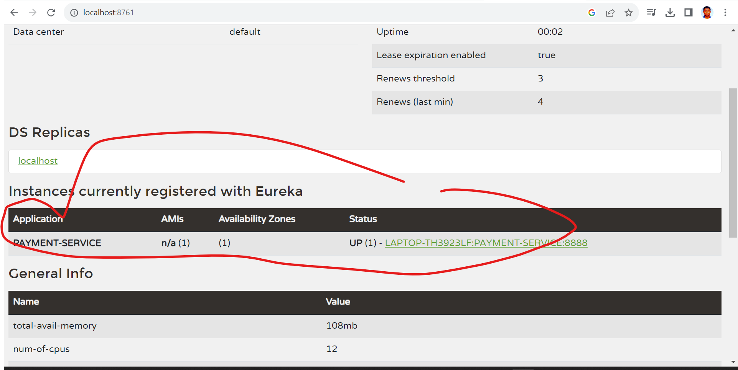

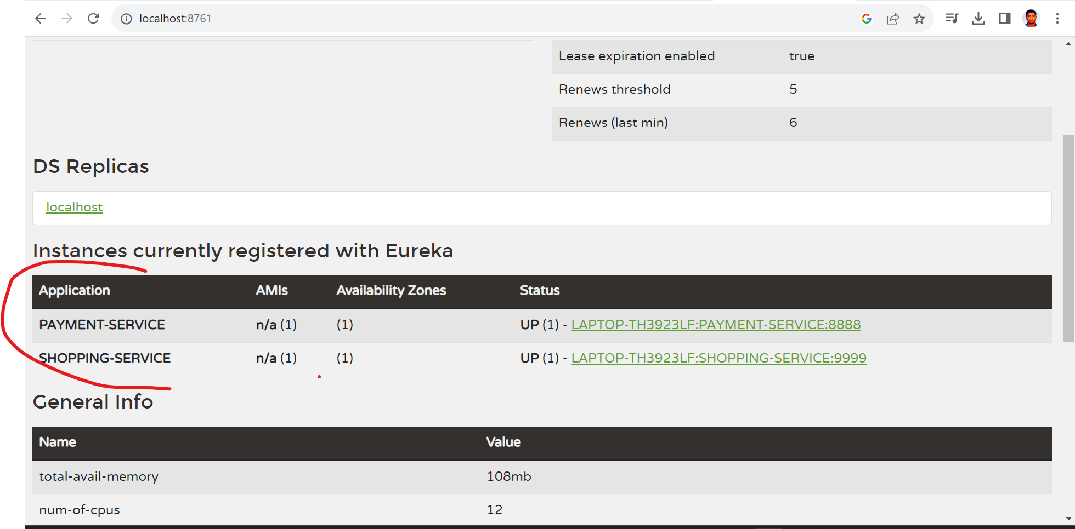

Old urls were:-

<http://localhost:8888/>..... & http://localhost:9999/....

So, our new urls will be

<http://PAYMENT-SERVICE:8888/>..... & <http://SHOPPING-SERVICE:9999/>....

<http://localhost:9999/amazon-payment/4999>

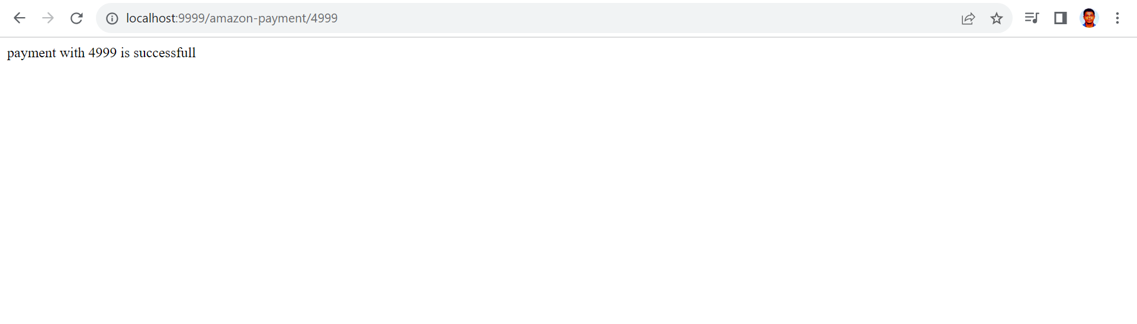

So, working fine.

Ref:- <https://www.youtube.com/watch?v=irBEdp7XlSQ&list=PLVz2XdJiJQxz3L2Onpxbel6r72IDdWrJh&index=2>

---For load balancing: -

Started service registry n running at 8761 port

Now, change port no of payment service to 8081 and create two more instance of it running at 8082 and 8083 using below steps:-

Now, create multiple instances of this appl.

->1. go to run configurations

->2. Duplicate -create duplicate instance of existing one

->3. open argument tab

->4. add the line : -Dserver.port=8082 -Dspring.profiles.active=production

Now, 3 instances of payment service is running n registered with eureka naming registry as below: -

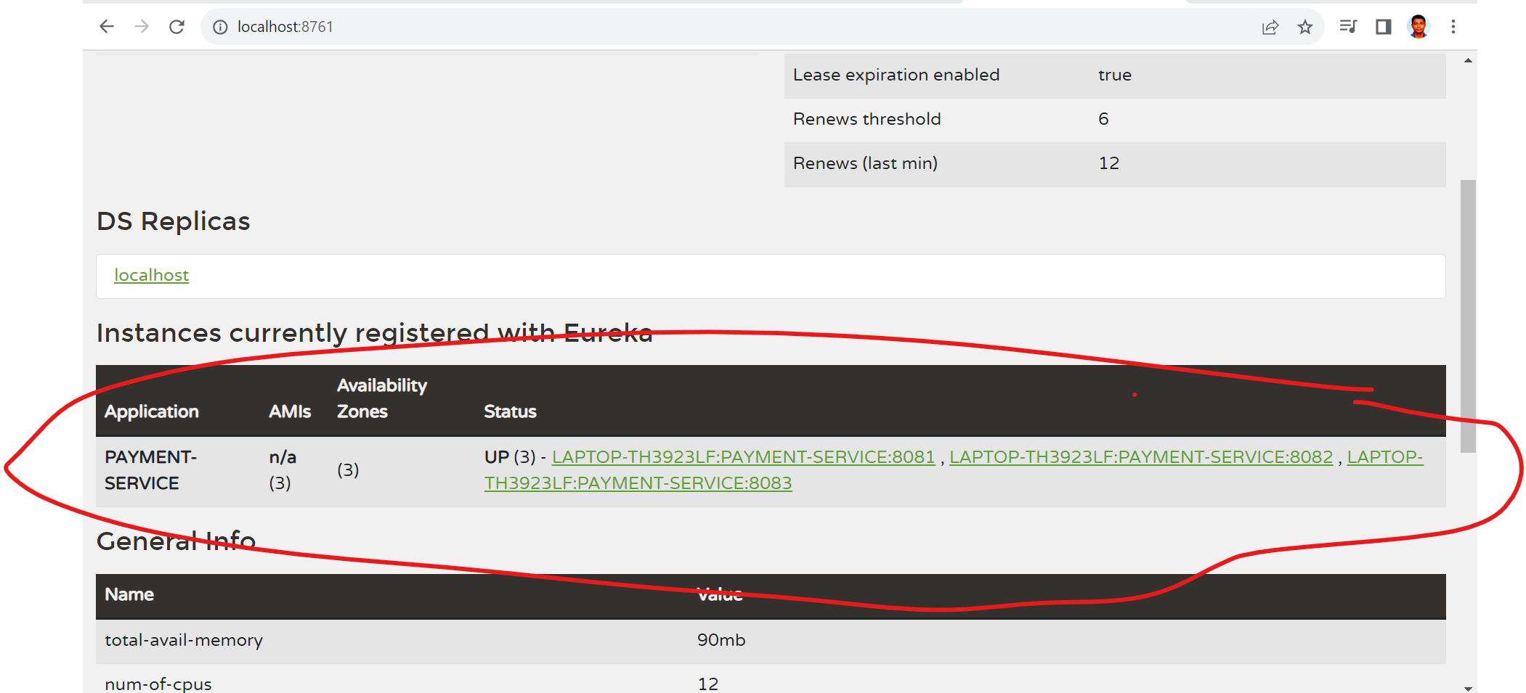

Now, in **shopping-service** which is client or user we need to add ribbon client dependency.

<dependency>

<groupId>org.springframework.cloud</groupId>

<artifactId>spring-cloud-starter-netflix-ribbon</artifactId>

<version>2.2.3.RELEASE</version>

</dependency>

And start shopping service

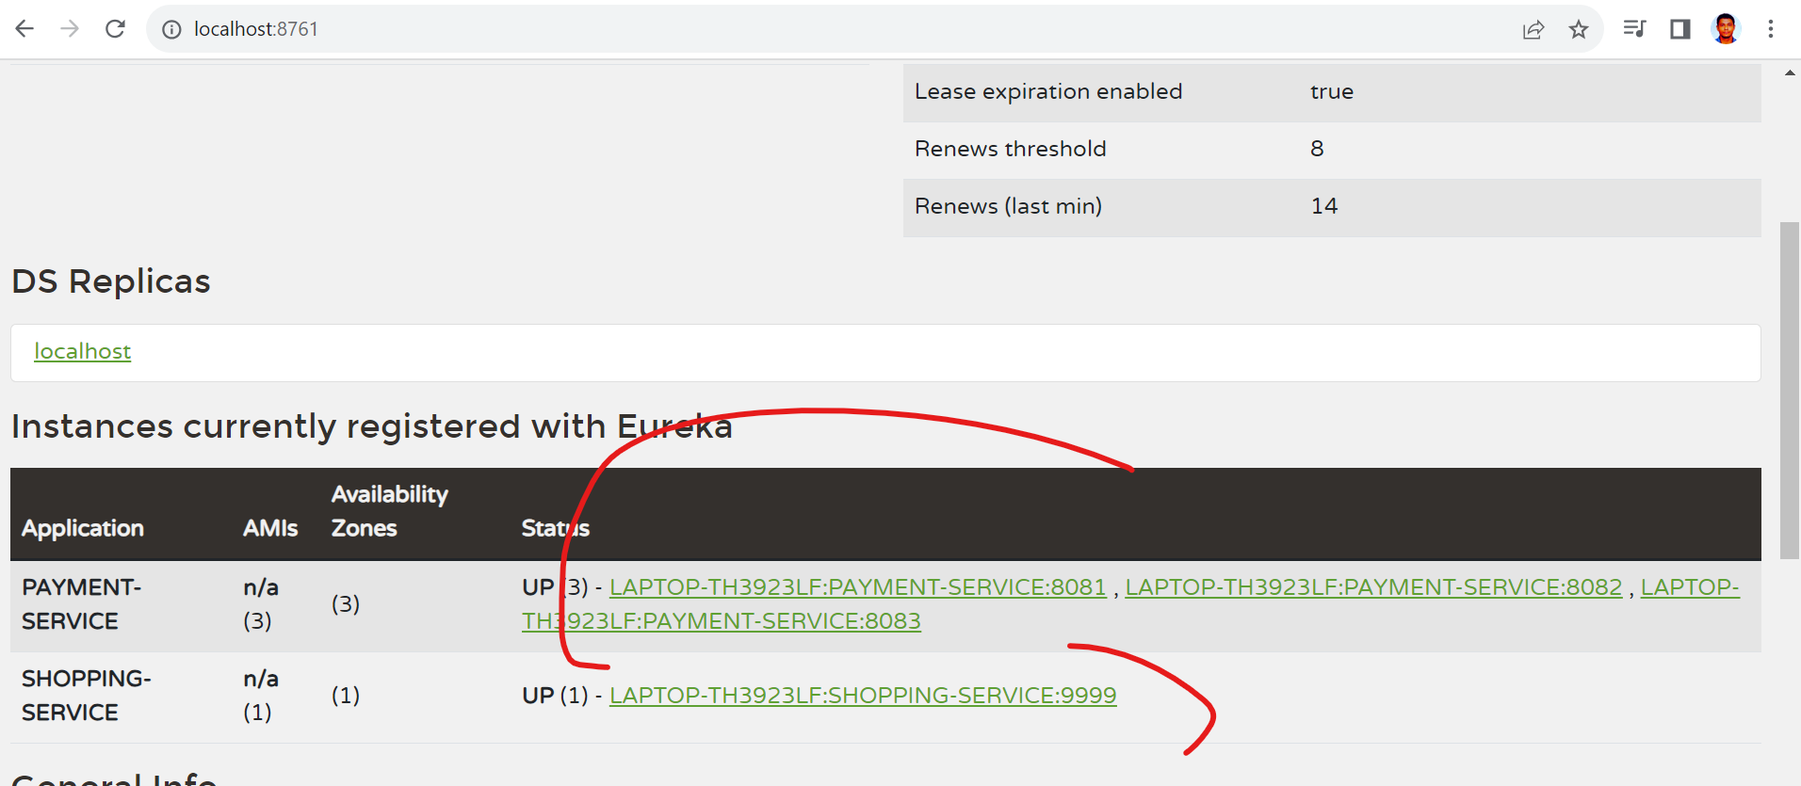

Now, 4 instances are running on eureka server.

<http://localhost:9999/amazon-payment/5000>

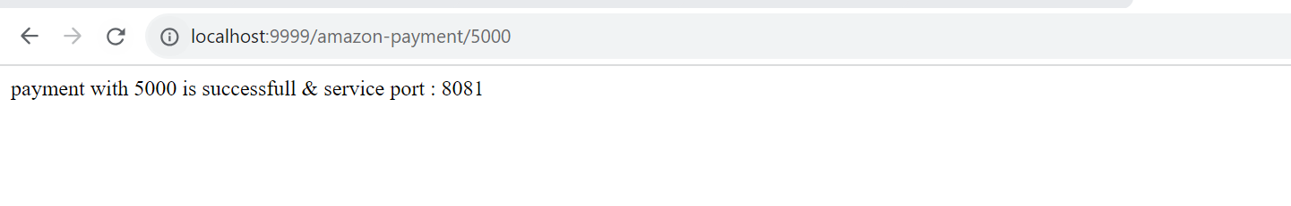

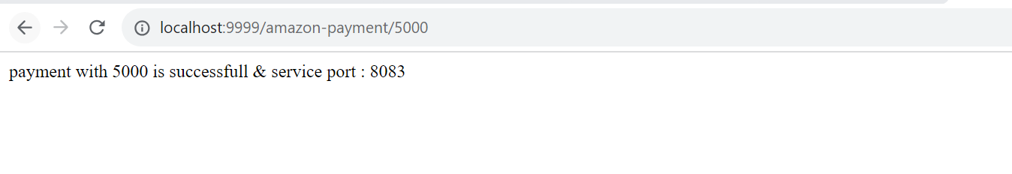

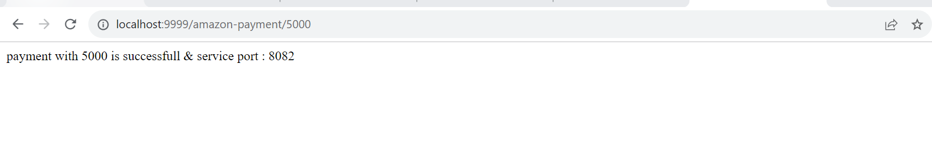

It’s following round robbin principle.

Diff request is going to diff instances.

Ref: - <https://www.youtube.com/watch?v=_e97OLyEEiA&list=PLVz2XdJiJQxz3L2Onpxbel6r72IDdWrJh&index=4>

Ref:- <https://www.youtube.com/watch?v=_e97OLyEEiA&list=PLVz2XdJiJQxz3L2Onpxbel6r72IDdWrJh&index=4>